**Standard Operating Procedure**

**On**

# AWS DATASYNC

**Document Control**

**Version History**

|  |  |  |  |
| --- | --- | --- | --- |
| **Version Detail** | **Date** | **Prepared By** | **Reviewed By** |
| V1 | 21/05/2023 | Ritesh Nagdive | Usama Mashayak |
| - | - | - | - |

### Contents

### 1.Introduction ……………………………………………………………………………………………………………………………………5

### 2.Prerequisite ……………………………………………………………………………………………………………………………………5

### 3.Steps………………………………………………………………………………………………………………………………………………..6

1. **Introduction**

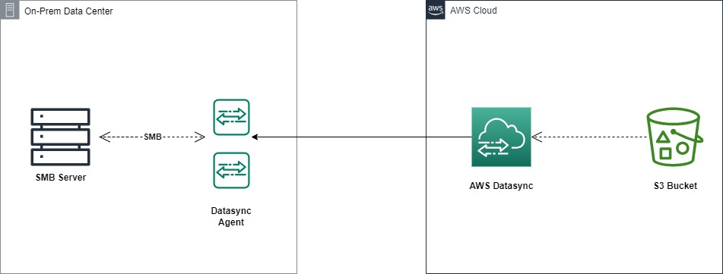

Figure 1: General overview of AWS Datasync

AWS DataSync is a fully managed data transfer service that allows you to accelerate moving large amounts of data online between AWS services or S3 and on-premises storage. In our case, we were using AWS DataSync to transfer data from an S3 bucket to on-prem Datacenter

1. **Prerequisite**

* AWS DataSync Agent Download from AWS Console
* VMware ESXi
* SMB On-Prem Server (port 139 or 445)

1. **Steps**

Step 1:

Login to vmvare workstation https://10.0.1.40/ui/#/login

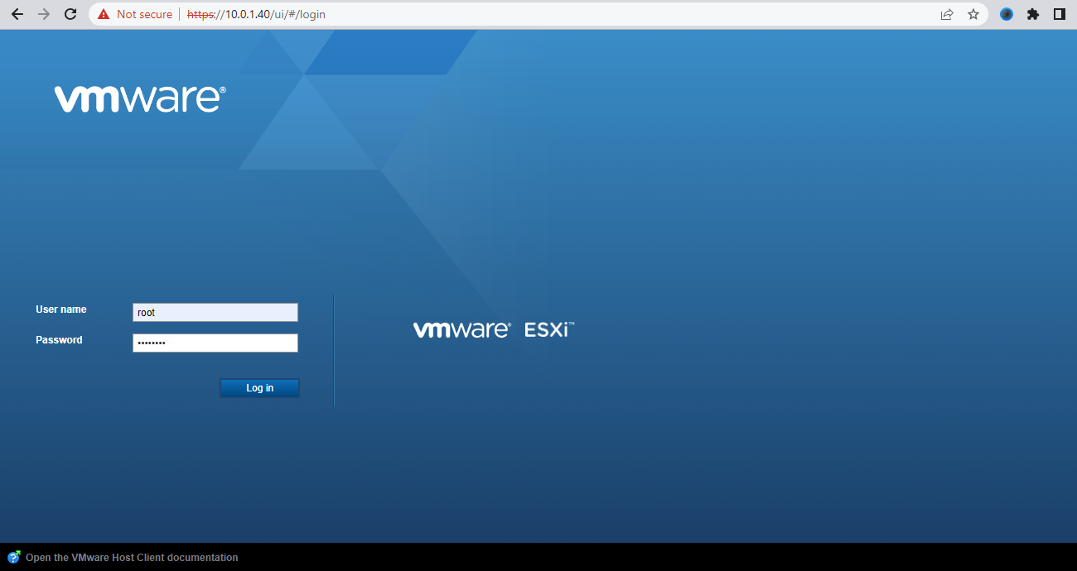

Step 2:

Create windows server on Vmware having IP 10.0.1.40

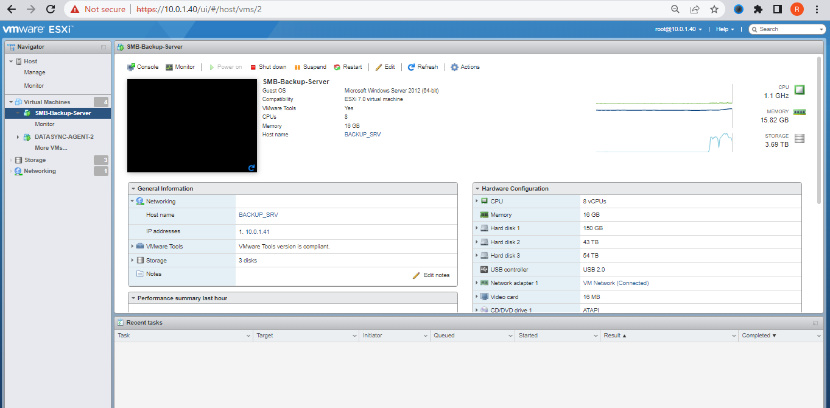

Step 3:

Create Two linux vm on Vmware name as

Datasync Agent-1 : 10.0.1.42

Datasync Agent-2 : 10.0.1.43

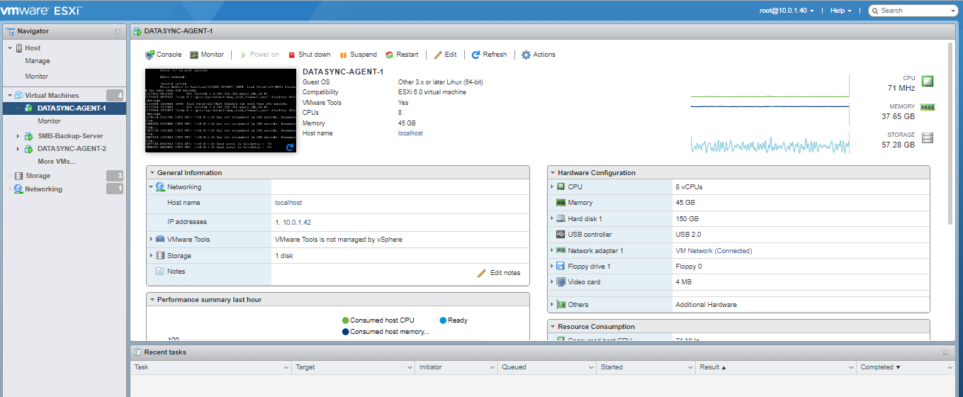

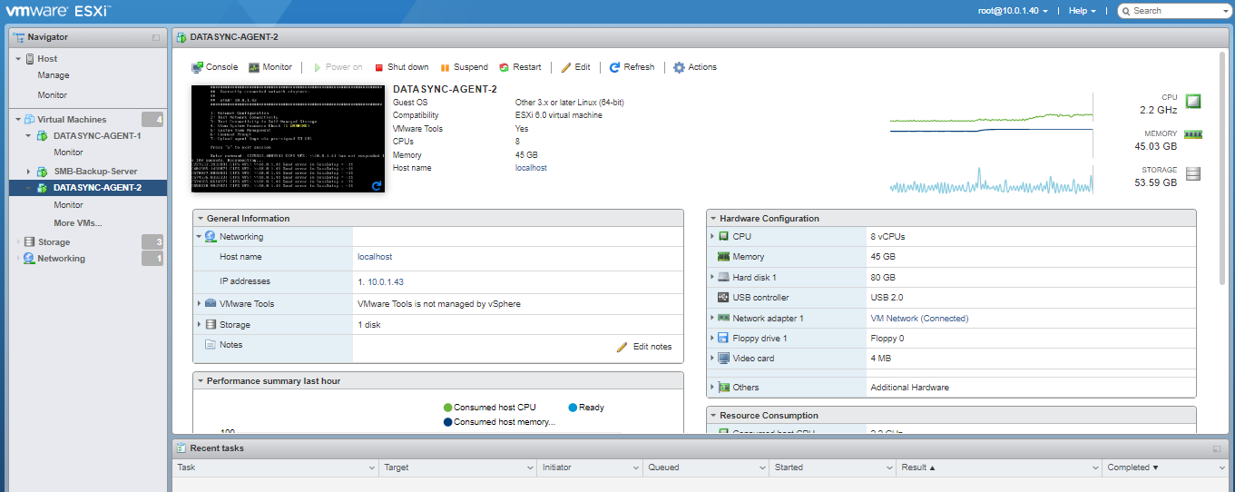

Step 4:

Log in to the AWS Management Console: Open a web browser and go to the AWS Management Console (console.aws.amazon.com).

Step 5:

Open the AWS DataSync service: Search for "DataSync" in the AWS Management Console and open the DataSync service.

Step 6:

Create a new DataSync agent: Click on "Create agent" and follow the instructions to create a new DataSync agent. Choose the appropriate options for your setup, including a name for the agent and download the datasync Image from the Datasync Console

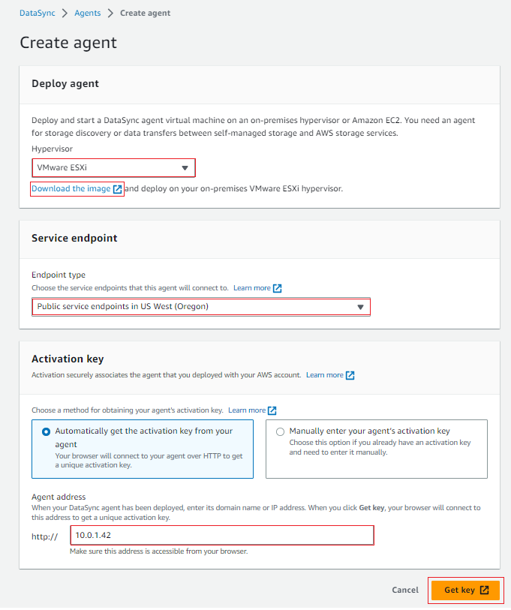

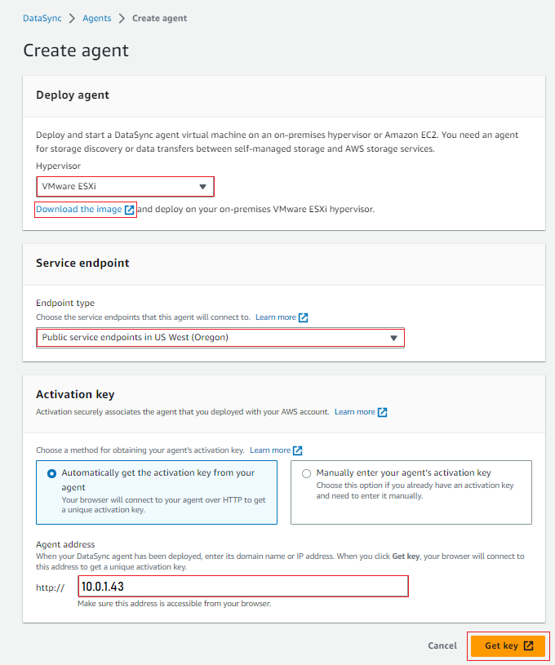

Step 6:

Once you download the datasync images in zip file then extract the .ova image file. While creating linux vm we have to upload the .ova file .

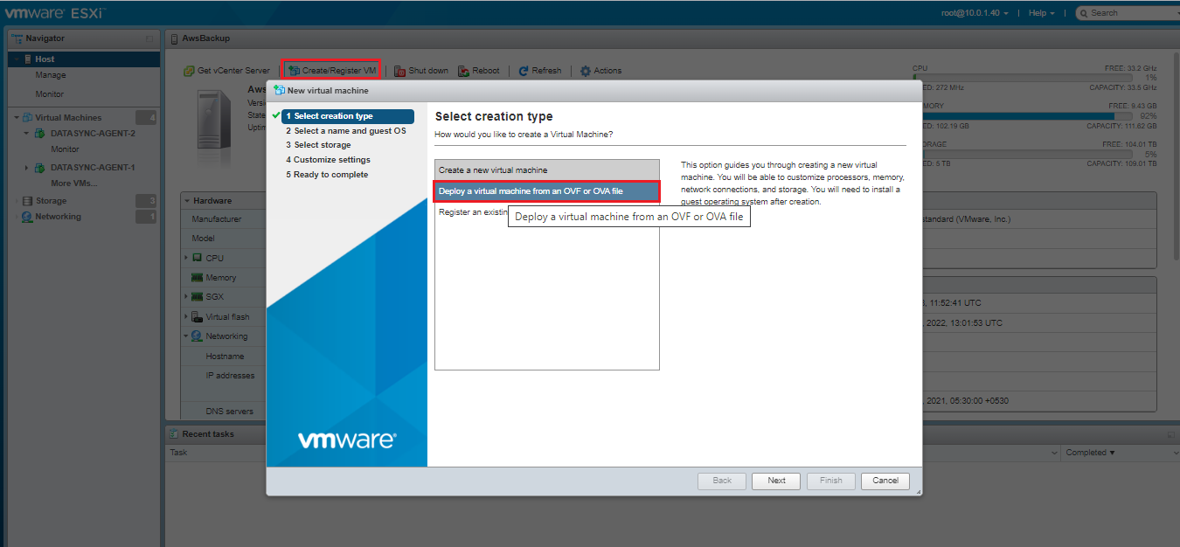

Step 7:

Set up a source location: Create a source location in the DataSync console. Select "Amazon S3" as the source type and specify the details of the S3 bucket where your data is stored.

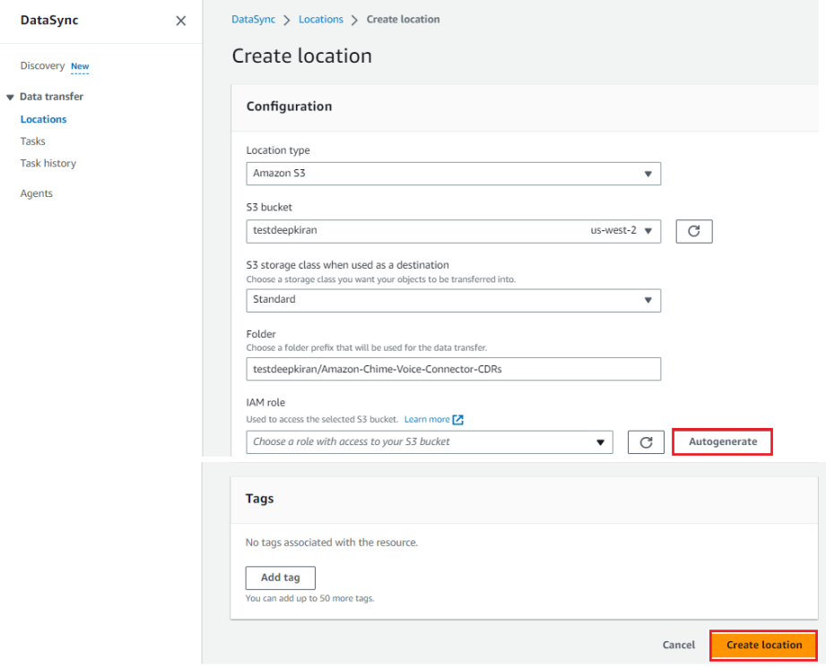

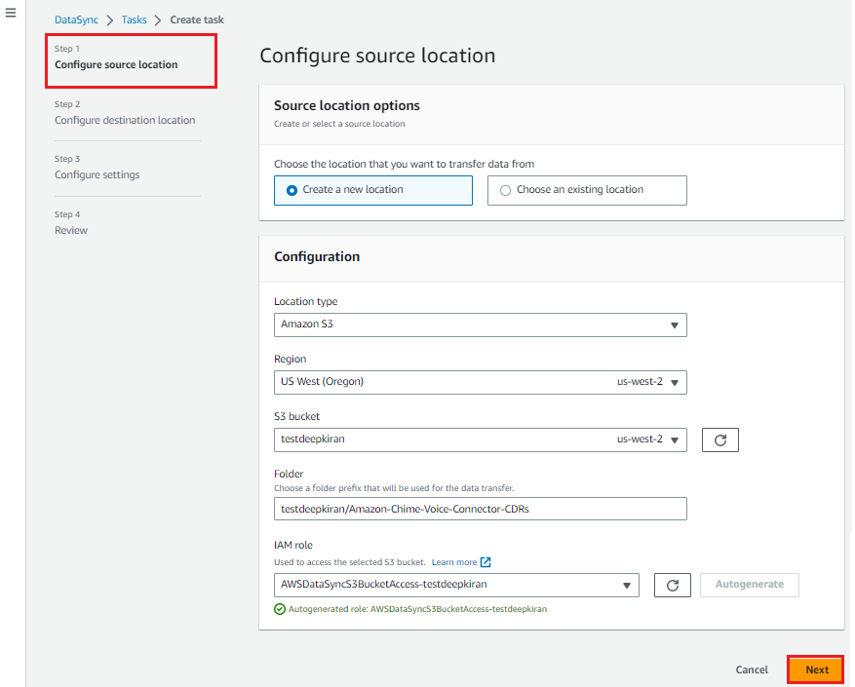

Step 8:

Set up a destination location: Create a destination location in the DataSync console. Choose "Server Message Block (SMB)" as the destination type and specify the details of your on-premise SMB server, including the IP address or hostname, shared directory, and any authentication credentials if required.

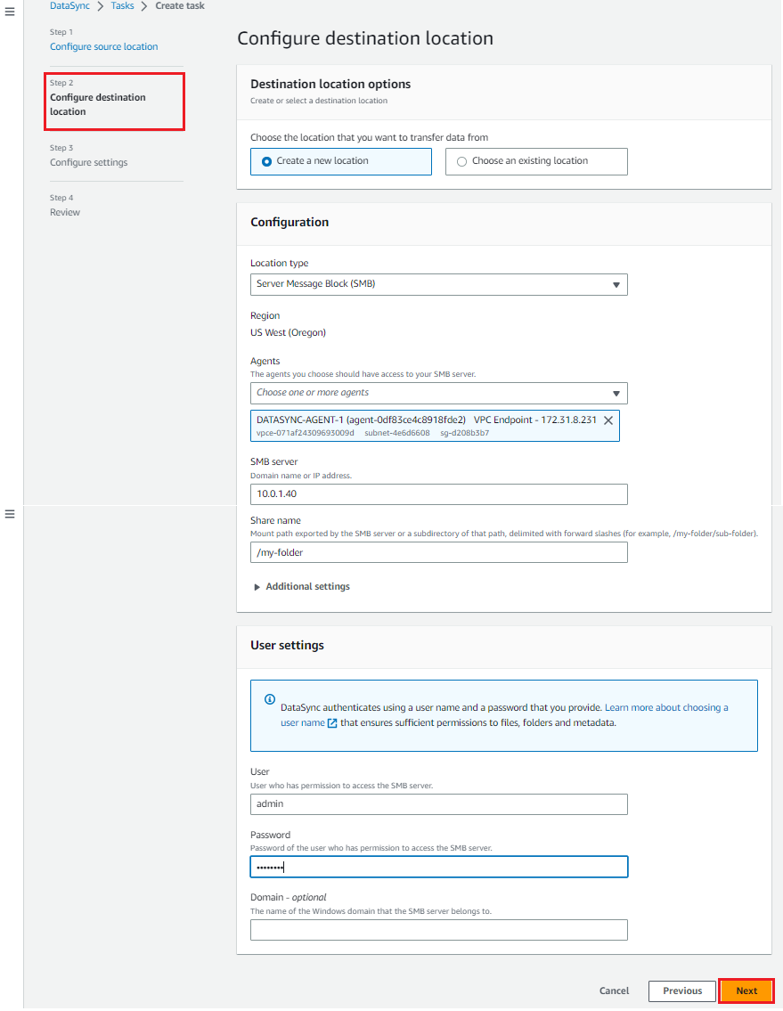

Step 9:

Create a task: Set up a new task in the DataSync console. Choose the previously created source and destination locations, and configure any additional settings for the task, such as scheduling options or data filters.

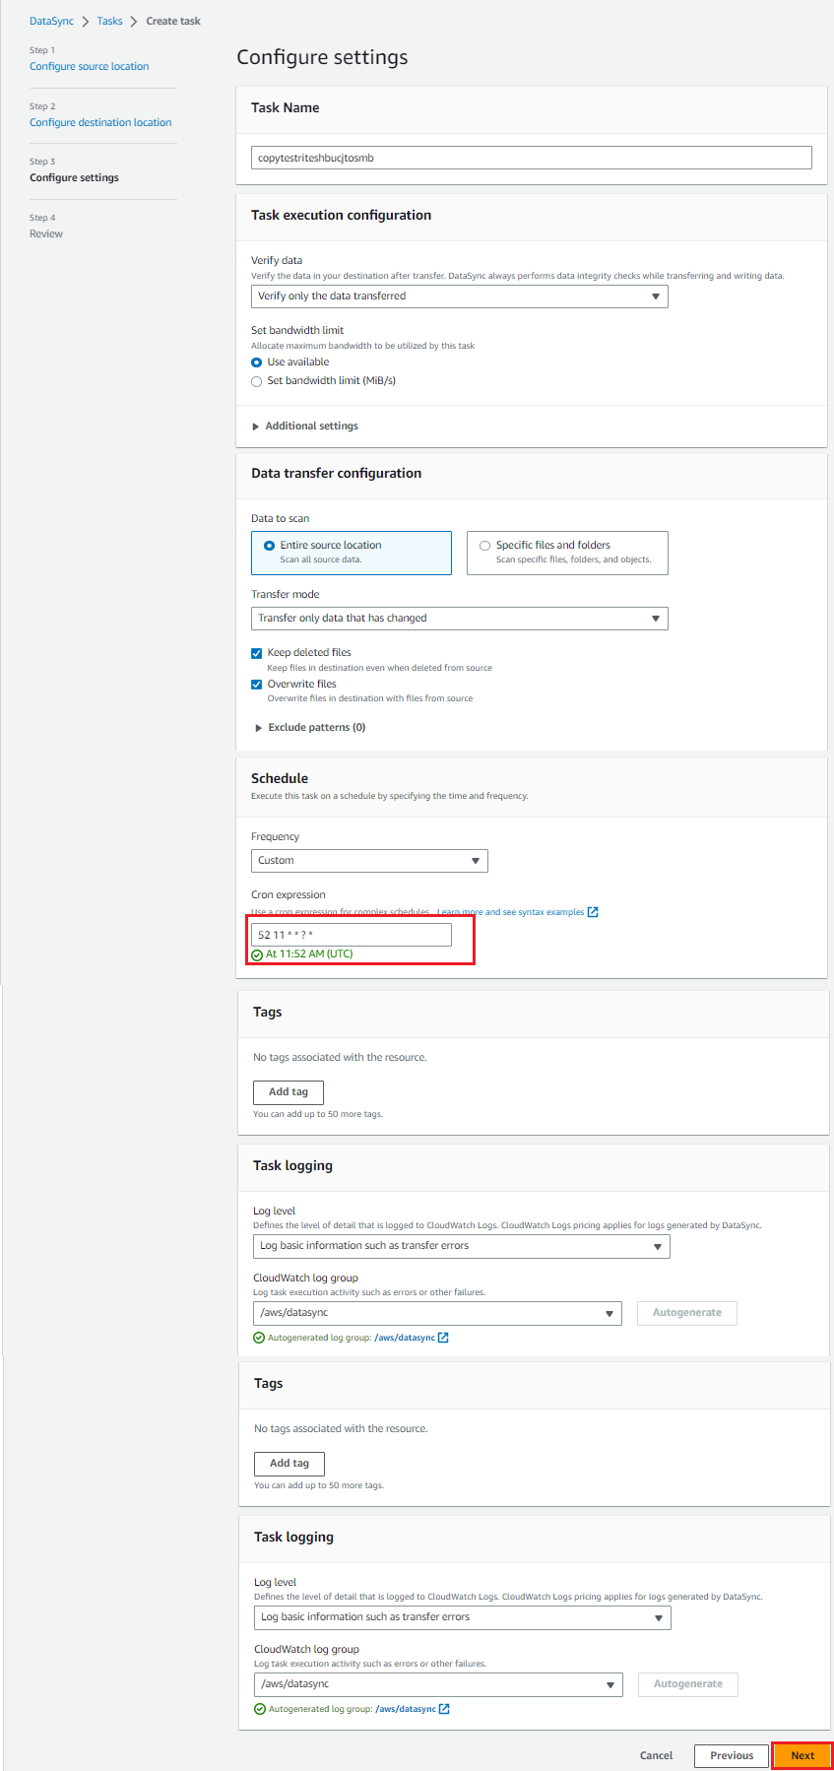

Step 10:

Review the configuration and Once the task is configured, initiate cron-job on particular time that we have set and the data will transfer from the AWS S3 bucket to your on-premise SMB server.

Note : If datasync task getting failed reboot the datasync agent and make sure that tasks are working fine